Local setup instructions
Lesson
Getting Started
- Step 1: Download or clone the starter repo here(opens in a new tab).
- Step 2: Download a copy of the ubuntu.ova file from AWS(opens in a new tab). Don't be concerned if it takes some time to download. If 30 minutes pass and the file has not downloaded, cancel and reattempt the download. If it's still not successful, please reach out to Udacity staff. (This OVA file is updated as of April 2021)
- Step 3: Download & install Oracle Virtualbox(opens in a new tab) software which will be used as our virtualization tool for loading the OVA file downloaded above. Refer to these instructions(opens in a new tab) on how to install Virtualbox on your respective local host OS.
  - Note that currently, VirtualBox does not support Apple’s M1, M2, and M3 chips for running virtual machines. While Oracle has released a beta version (VirtualBox 7.0) that adds some level of support for Apple Silicon, it is highly unstable and not recommended for regular use. See this list of the supporting host OSes(opens in a new tab).
  - For configuring the VirtualBox, you must enable the hardware virtualization on the host machine. These threads may help:
    - How to enable support of CPU virtualization on Macbook?(opens in a new tab)
    - Enabling Virtualization in your Windows PC BIOS(opens in a new tab)
- Step 4: Download and Install Docker Desktop from its official website. Depending on your operating system, you can follow one of the below links to download and set up docker on your computer.
  - Windows(opens in a new tab)
  - MacOS(opens in a new tab)
  - Linux(opens in a new tab)
In this project, you will use Docker to run the GVM tool. Alternatively, you can run the GVM as a VM in the Virtualbox.
Installation
As soon as the Virtualbbox tool starts, ensure that the Virtualbox >> File >> Host Network Manager has a host-only network available.
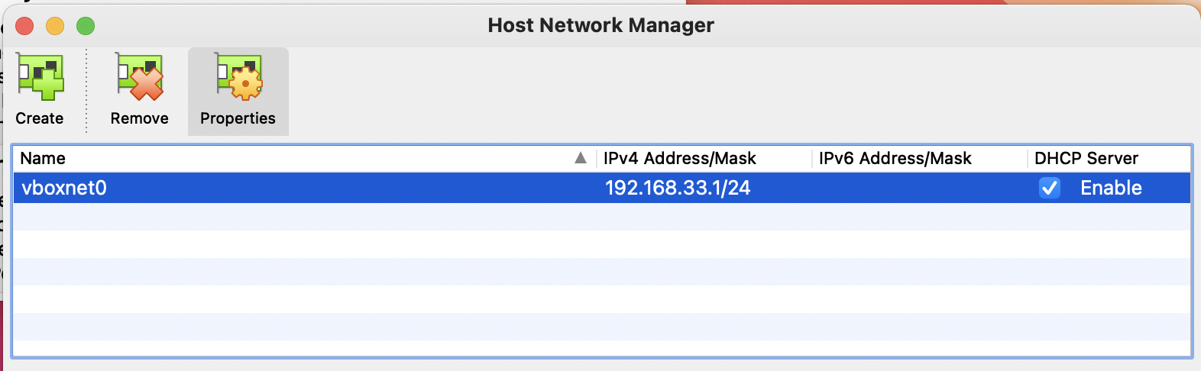
Verifying the Virtualbox >> File >> Host Network Manager settings
- Step 1: Load the OVA file - Double click or right-click on the OVA file to load it in Virtualbox. You will be presented with an Appliance settings page which will reflect the virtual machine’s settings and configuration. Click on Import to begin creating the virtual machine on your computer.
Allow the installation to complete. It will take a few minutes before the virtual machine is up and running.
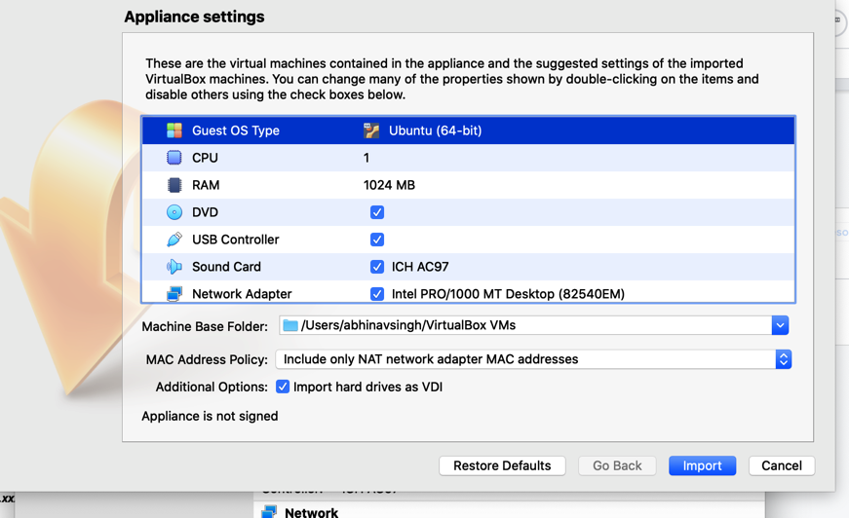
No Need to Change the Settings! Just Click "Import"
- Step 2: Configure the VM Network Settings - Your VirtualBox Manager will now be reflecting the virtual machine. Go to VM's Settings >> Network tab. Make sure to choose the following adapters:
  - Adapter 1 - Choose NAT. This is useful if you want to access the server running on a specific port in the VM from the host browser. Choosing NAT requires you to do the port forwarding. NAT also allows your VM to access the outside Internet.
  - Adapter 2 - Choose Host-only. This will allow VM to VM communication. This will allocate your VM an IP from the DHCP (virtual) network.
  - Adapter 3 - Choose Bridged. This will allow you access the VM from the host. In addition, this mode also supports VM to VM communication. This is particularly useful is you'd have to scan the current VM from another VM (GVM VM).
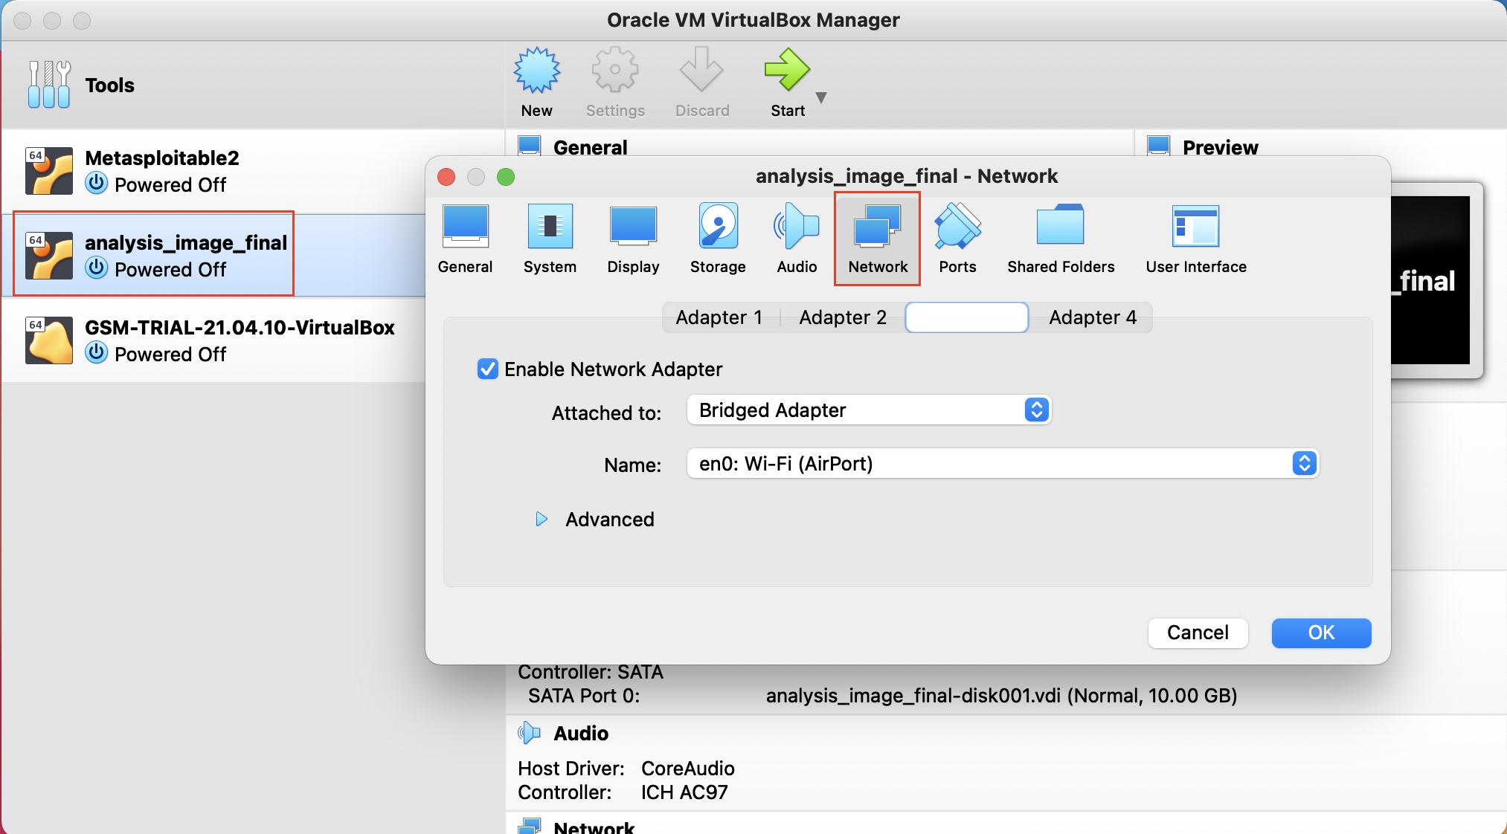
Ensure to choose all three Adapters carefully.
- Step 3: Start the VM - You are now ready to launch the virtual machine. Click on "Start" to begin loading the Ubuntu OS as your virtual machine.
- Step 4: Login Keep a note of the default username and password of the ubuntu linux which is already created for you.
Username: ubuntu
Password: ubuntu
- Step 5: Find the IP address Once the Desktop is loaded, open the terminal in Ubuntu and run the command ifconfig to list the available interfaces and their IP addresses. Note the IP address associated with eth1. It should be in the form of 192.168.xxx.xxx.
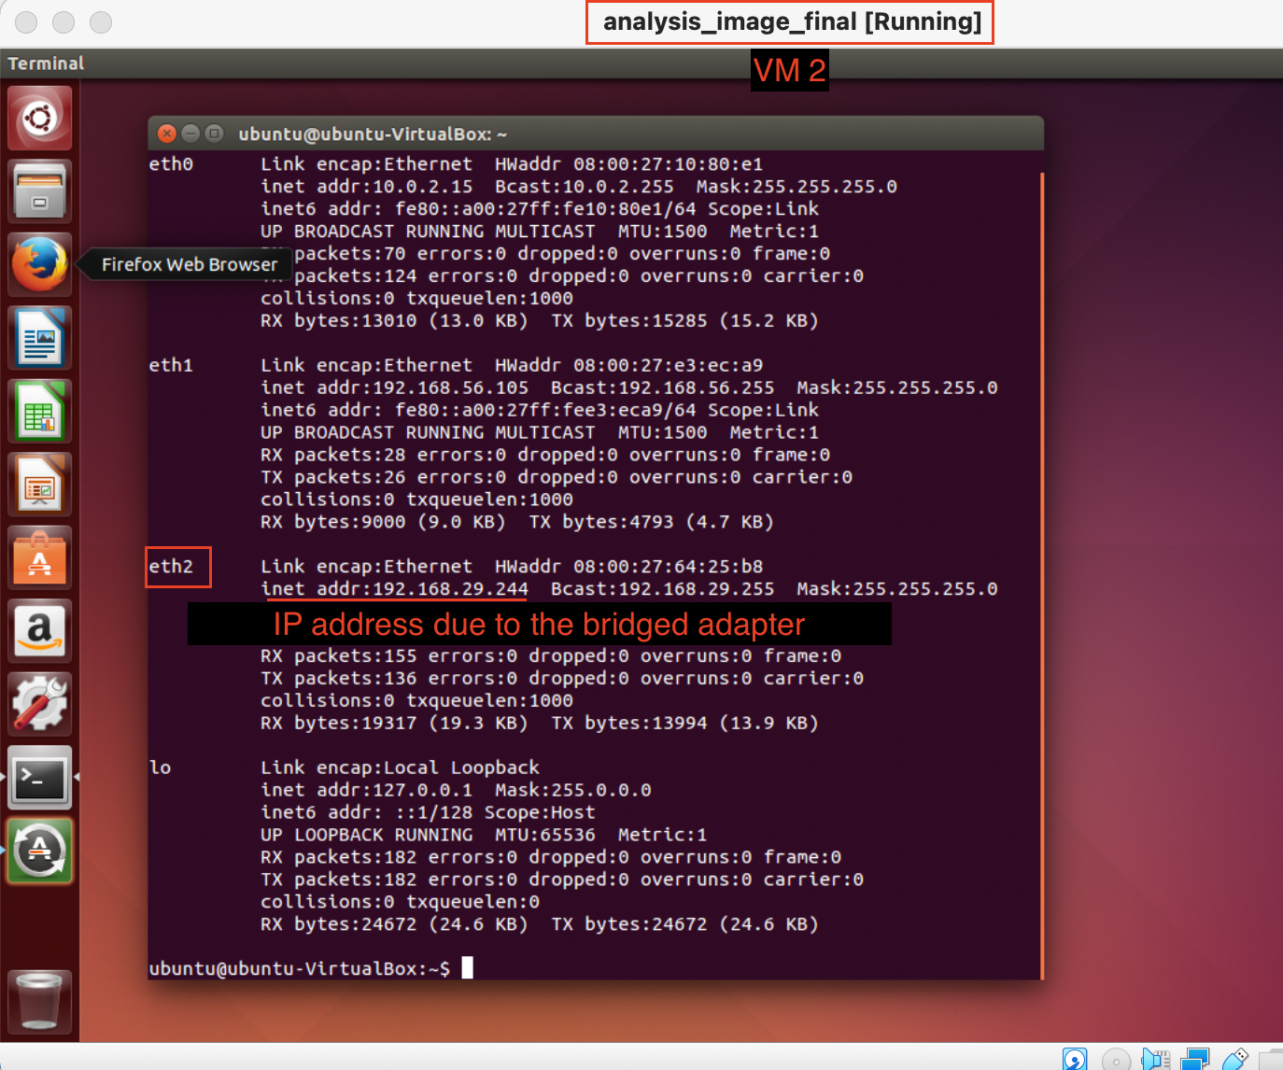
Finding the IP address
Testing
- Step 1: Open the terminal in Ubuntu VM and run the command ifconfig to list the available interfaces and their IP addresses.
- Step 2: Note the IP address associated with eth1. It should be in the form of 192.168.xxx.xxx.
- Step 3: Come back to your host operating system and launch the command prompt or terminal. Run the command:
ping 192.168.xxx.xxx
If the packets are successfully getting delivered, it means that your guest operating system (virtual machine) is accessible from the host operating system.
Troubleshoot
- VM Aborts abruptly: If the VM aborts shortly after startup, try starting VirtualBox using the terminal: If that doesn't work, try these steps:
  - Go to File > Import Appliance > Expert Mode >. Uncheck box for Import hard drives as VDI
  - Import Security Onion OVA
  - Right-click VM in the manager. Go to Settings > Display > Screen > Increase the Video Memory
- USB 2.0 Controller Not Found error
This error can be removed by navigating into OVA file's settings in Virtualbox. Inside the Settings tab, select the Ports tab and disable the check mark against Enable USB controller. This will remove the USB controller from the image. Save it and restart the virtual machine.
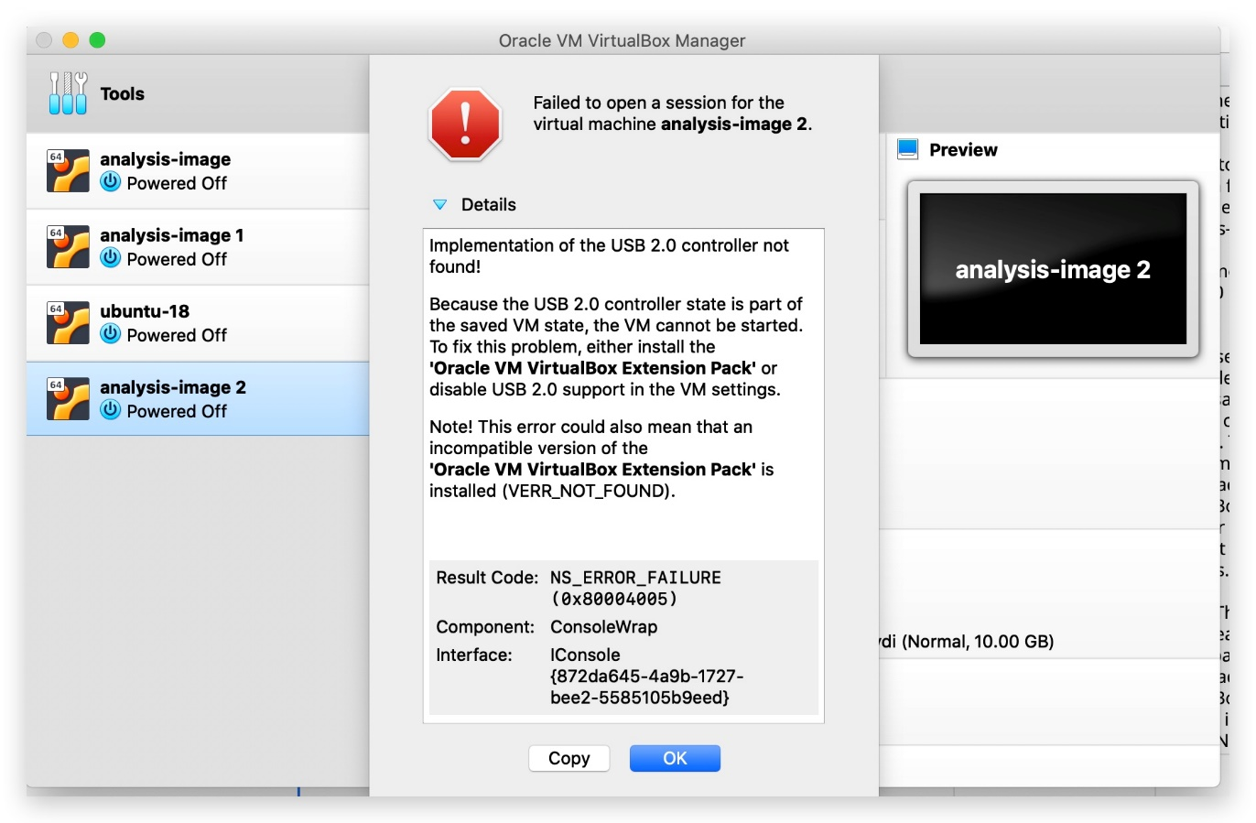
USB 2.0 Controller Error
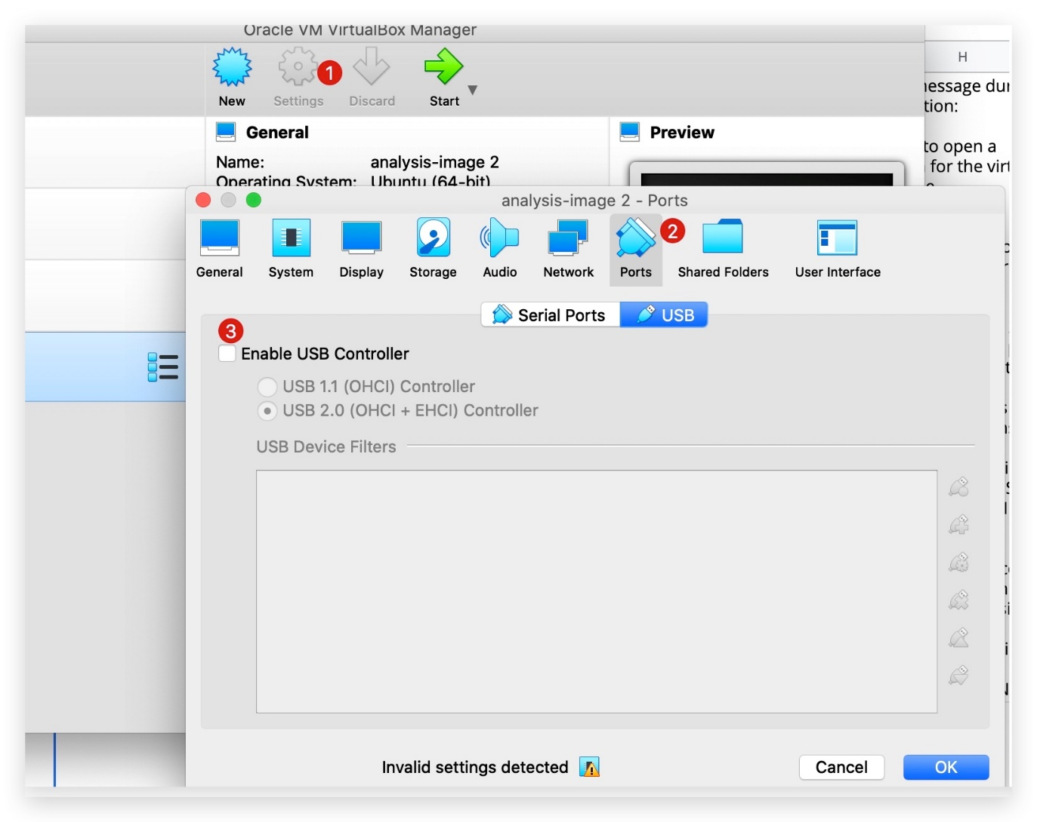
Settings to Remove the USB 2.0 Controller Error
- How do I ensure I have the right OVA file downloaded?
It's easy to check the ND5 checksum of the downloaded file.
# Feel free to change the filename, as applicable to you
md5 2021_analysis_image_final.ova
The expected output should be exactly same as shown in the snapshot below.
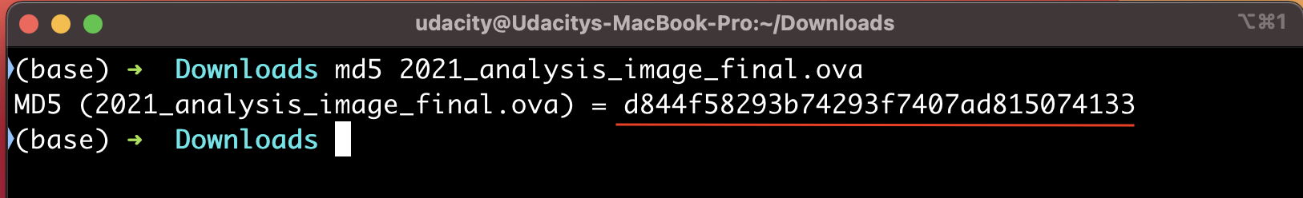
Viewing the MD5 checksum of the downloaded file

What Are We Doing?

South Udan and North Udan
South Udan is a small island nation that is a peaceful and technologically advanced nation! Because of its small size, the country believes in efficiently using its land and natural resources. Their scientists recently came up with a novel and cleaner means of performing nuclear fission of an element called Tridanium. This allows them to generate 100 times more energy and drastically reduce nuclear waste, thus making it the most efficient and clean way to generate electricity. This enabled them to generate cleaner and cheaper electricity, thus improving the lives of their citizens.
North Udan was extremely jealous of the progress of their neighbors. They still rely on using coal and other fossil fuels which are known to speed up global warming. In order to disrupt South Udan program, the government of North Udan decides to launch a cyberattack on South Udan Tridanium processing plant and disrupt its operation.
The National Peace Agency of North Udan, which is an undercover organization that runs the nation-state espionage program, launches an attack during a national holiday in South Udan (the holiday marks 50 years of border separation of the two nations). They manage to compromise a linux server which serves as a jump host to connect the Tridanium processing plant to the internet. They attempted to brute force the password of an employee account which triggered a security alarm. You have been immediately called onboard to respond to the security alarm and contain the ongoing cyberattack. You will begin the investigation from the compromised jump box to detect and mitigate the threats. Since it's a mission-critical server, you are also tasked with immediately hardening the server to proactively defeat future attacks from North Udan.
Project Rubric
Before starting the project, it is advisable to have a quick look at the rubrics page in the left bottom of the screen, against which Reviewers will evaluate your submission.

Section 1: Threat Detection

What Happened?
Task 1: ClamAV scan
As a first threat detection measure, you will have to perform an antivirus scan on the system to determine the malware files planted by the National Peace Agency on the processing plant’s server. Launch ClamAV malware scanner and perform a scan on the ‘Downloads’ directory (/home/ubuntu/Downloads/). Report all detections in the clamAV_report.txt file.
Note: The VM has an older version ClamAV 0.100.3 installed, which is inherently blocked from downloading new updates. See this End of Life(opens in a new tab) policy for specific details. Therefore, you cannot update the virus database using the freshclam command. However, you can still complete the task above without updating the ClamAV.
Task 2: Suspicious File Identification
You know that the National Peace Agency has an advanced infiltration group. As a curious investigator, you still want to explore other files available in the Downloads folder, despite the ClamAV scan detecting some files as malware. Can you spot one more suspicious file which should have been a cause of infection but managed to defeat your ClamAV scan? Find this filename and the embedded callout URLs hardcoded in this file. This callout domain is the Command & control server of the National Peace agency. Report this finding in the file suspicious_file_report.txt.
Task 3: Yara Rule Creation
Once you have ensured the presence of a unique malware file that could not be detected through ClamAV scan, you also want to ensure that there is a signature or rule in place so that you can scan your other servers for the presence of the same file. Create a Yara rule file named unknown_threat.yara which can be compiled with ClamAV to detect the unique malware you have identified in the task above.

Section 2: Threat Mitigation

What Will We Do About It?
Task 1: Implement HIDS
The first security alarm about the ongoing cyberattack came from the Host-Based Intrusion Detection System is about multiple failed login attempts from a foreign IP address. Launch the host IDS and analyze the logs and events captured in the system. To verify that the IDS is up and working, try connecting to the virtual machine via SSH and notice the new login entry created in the IDS web UI. Take a snapshot of the newly created log lines and name it succesful_ssh_logon.png. This will ensure that the IDS system is working as expected and capturing logs in real-time. Once you have taken the snapshot, upload it to the /starter/section_2/ directory in Github.
Task 2: Locate Suspicious IP
Once you have verified that the IDS is working fine, you are now required to collect the next indicator of compromise(IoC), which is the IP address that attempted to break into the system. This IoC will prove significant in attributing the threat actors behind the cyber attack. You were told that the initial security alarm consisted of multiple failed login attempts on the jump host server. To verify that, filter the IDS alerts to specifically look for failed logins followed by a successful one. To further disrupt the network after a successful login, the attackers execute a command to elevate their privilege to system root. Your goal is to identify that IP address which made the logon attempts and then performed privilege escalation to the ‘root’ user. Report the IP address in the attacker_IP.txt file.
Since the attack happened in the year 2020, and that's when we captured the OVA image. Make sure that you are looking for the logs during that time frame.
Task 3: IPtables Rule
Once you have identified the attacking IP address, you are now required to create an IPtables rule to make sure that any SSH connection requests from this host are blocked in the future. Hopefully, this will stop this agent from the so-called National Peace Agency from connecting again. Report your IP table rule in the Iptable_rule.txt that will deny SSH access to the attacking IP.
Task 4: Detect Backdoor Username, Process & Port
Once the attackers managed to break into the system, they created a backdoor username and launched a process that allows them to log in through a non-standard port number. This is a common tactic implemented by nation-state actors to ensure continuous access to the compromised system. Your goal is:
- Identify the rogue username: Analyze the logs to find the rogue user added to the system. Once you have the username, you'd want to view the /var/log/auth.log to check for the authorization events. Next, fetch all processes that are currently running for that user.
- Locate the malicious process: Consider that the newly created rogue user has sufficient permissions to use the root credentials to run the backdoor process. Therefore, you will not find a process running in the name of the rogue user. Instead, the backdoor process will be running as root. Analyze the currently running processes to find that suspicious process.
Tip: Investigate the http://localhost/ossec/(opens in a new tab) IDS logs for the bruteforce attacks.
- IP address/port: Once you have the process name with you, find the "non-standard" port it is listening on.
Both IDS logs, as well as system commands, can be used to perform this task. Report these three details, along with a justification, in the backdoor_details.txt file.
Delete the rogue username and kill the backdoor process to remove the persistence created by the attackers.
Task 5: Disable SSH Root Access
So far, we have figured out that the attack was carried out through brute-forcing ssh login credentials. Can you update the SSH configuration file to ensure that root login through SSH is never allowed, even if the correct set of credentials have been used? Report your changes by modifying the respective configuration entry and providing a snapshot of the change you have made. Name the file as remote_config_change.jpg.
As an optional stand out task, you can also provide a set of best practice recommendations to the senior leadership about further securing the remote login process and password management in the organization. While you appreciate the job security, you also don't appreciate the National Peace Agency making you come in on your day off. Provide your recommendation in the additional_remote_security_recommendations.txt file.

Section 3: System Hardening for Enhanced Security

Time for Implementation!
Task 1: OpenVAS Scan
Now that the cyber-attack has been successfully contained, you are also tasked with further hardening the jump host server. As a first step, perform an OpenVAS vulnerability scan on the system and provide a snapshot of the vulnerabilities identified by the scan. Name the snapshot asopenvas_vulnerability_report.png.
Task 2: Patching Apache
Once you have provided your report on the existing vulnerabilities on the system, you notice that the jump host is also running an Apache HTTP server which can be accessed from the internet and can serve as an attack point in future incidents. To harden the Apache server, you must remove the version banner from being publicly visible. This would make it difficult for an attacker to perform reconnaissance on the server and launch attacks. Your goal is to identify and report the current Apache httpd server version and then the configuration change required to prevent the version number from being publicly accessible. Report both these details in the filename apache_version_patching.txt.
Task 3: De-Privilege Apache Account
As a final task of hardening the system, you want to ensure that Apache always runs as a low privileged user with restricted system access. To do that, create a new user group called “apache-group” and a new user account called apache-user. Can you list the configuration changes you’ll have to make sure that Apache launches with this new user account and group name? Provide your response in apache_user_account.txt.
Optional Stand Out Task:
The head of security for South Udan is grateful to you for your services. They want to award you with a commendation, and you are asked to prepare an “Executive Summary” of the entire investigation and changes you have made to contain the threat. This executive summary will be used to brief the head of South Udan about the incident. You can provide your summary in the form of a PDF, Word or text file, depending on whether you want to use only text or add images. Name the file as “Executive_summary” and upload it to the section 3 directory itself.

Rubric
Use this project rubric to understand and assess the project criteria.

Threat Detection
Criteria | Submission Requirements
Implement malware detection and remediation through system scanning. | Use the ClamAV malware scanning tool to find:  - Infected filenames  - Malware detection names  List these in clamAV_report.txt.
Detect and assess specific properties and actions performed by the identified malware files and scripts. | Find:  - One more executable suspicious file from the directory which was not detected during the ClamAV scanning phase.  - All suspicious call out domains they can spot in the file.  List these in suspicious_file_report.txt.
Use the knowledge of a new strain of malware to write Yara rules and defend against the possibility of the malware bypassing the existing defense controls on the system. | Write and compile a Yara rule to detect the file which was undetected during the ClamAV phase. While writing the rule, the callout domain should be used as the pattern matching string. On compiling the rule, it should now detect the missed file.  Submission should be the rule file named as unknown_threat.yara.

Threat Mitigation
Criteria | Submission Requirements
Implement host-based IDS to monitor and respond to security events on the systems. | Launch the host IDS and interpret the logs and events captured in the system. To verify that the IDS is up and working, try connecting to the virtual machine via SSH and notice the new login entry created in the IDS web UI.  The IDS should capture the new user authentication and login. The IDS system must be working as expected and capturing logs in real-time.  Submission should be a screenshot labeledsuccessful_ssh_logon.png uploaded into /starter/section_2/ directory.
Implement policies and controls to defend against ongoing infection and operation of the provided malware. | Provide an iptable rule which blocks the suspicious IP address from attempting to access the SSh server.  Report your IP table rule that will deny SSH access to the attacking IP in Iptable_rule.txt.
Identify indicators of compromise related to advanced threats and take relevant actions to fix them. | Identify a new user account added on the server due to the successful compromise of the server. Both IDS logs as well as system commands can be used to perform this task.  Your goal is to identify the rouge username added by the attackers, locate the malicious process, and the remote port it is listening on.  Report these three details in the backdoor_details.txt file. Delete the rouge username and kill the backdoor process to remove the persistence created by the attackers.
Apply security best practices to secure remote login services on the system. | Update the SSH configuration file to ensure that root login through SSH is never allowed, even if the correct set of credentials have been used.  Report your changes by modifying the respective configuration entry and providing a screenshot of the change you have made. Name the screenshot remote_config_change.png.  Once the configuration change has been made, change your root password to further ensure that the attackers won't be able to use sudo to elevate their privilege to root.
[OPTIONAL STAND OUT TASK] Provide additional security best practice to secure remote access and password management. | Provide additional steps that can be taken to secure remote system access along with improving password policies for enhanced security. Add your recommendations in additional_security_recommendations.txt.

System Hardening for Enhanced Security
Criteria | Submission Requirements
Perform a system scan to identify existing vulnerabilities in 3rd party software libraries. | Install and execute openVAS vulnerability scanner to check the entire system for the presence of vulnerabilities and unpatched issues.  Provide a snapshot of the vulnerabilities identified by the scan. Name the snapshot as openvas_vulnerability_report.png.
Identify and correct misconfigurations in system access and permissions settings of 3rd party applications. | Remove the version banner from being publicly visible. Your goal is to identify and report the current Apache httpd server version and then the configuration change required to prevent the version number from being publicly accessible.  Report both these details in the filename apache_version_patching.txt.
Make configuration changes to harden the application software along with defining their access rights and privileges. | Identify the current account Apache is running as. In order to improve the system security, set up a new non-privileged group called ‘apache-group’ and add a user called ‘apache-user’. Then change Apache’s installation directory ownership to the newly created ‘apache-user’ account. Provide the name of the configuration file and the exact log lines that you would change to ensure that apache launches as the newly created user account.  Provide your response in apache_user_account.txt.
[OPTIONAL STAND OUT TASK] Prepare and deliver an executive summary of the entire cyber attack in the form of a document or presentation. | Prepare an “Executive Summary” of the entire investigation and changes you have made to contain the threat.  Provide your summary in the form of a PDF, Word or text file, depending on whether you want to use only text or add images. Name the file “Executive_summary” and upload it to the section 3 directory itself.

Suggestions to Make Your Project Stand Out
- Provide additional security best practices to secure remote access and password management.
- Prepare and deliver an executive summary of the entire cyber attack in the form of a document or presentation.

